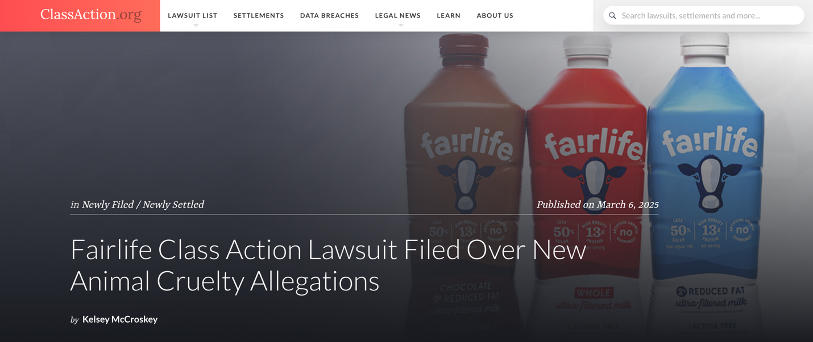

Published on March 6, 2025
Fairlife Class Action Lawsuit Filed Over New Animal Cruelty Allegations
by Kelsey McCroskey

Fairlife, parent company Coca-Cola and several affiliates face a proposed class action lawsuit that challenges the Fairlife brand’s purported commitment to humane animal treatment and sustainability, particularly in light of new reports of animal cruelty at “unprecedented” levels across the brand’s supply chain.

Get the latest open class action lawsuits sent to your inbox. Sign up for ClassAction.org’s free weekly newsletter here.

The 88-page lawsuit alleges that the defendants—which also include Fairlife’s dairy farming and supply operator Select Milk Producers and two individuals who co-founded Select Milk and Fairlife—have propagated “egregiously false” and misleading claims that Fairlife cows receive above-standard care and do not suffer abuse or neglect.

According to the filing, Fairlife charges a premium price for its lines of “filtered milk” products, Core Power protein drinks and ice cream based on assurances that the brand provides high-quality, humane animal care. However, new investigations conducted by animal welfare organization the Animal Recovery Mission (ARM) between July and December 2024 reveal that certain Fairlife suppliers are “massively concentrated industrial farms” plagued by systemic animal cruelty and severe neglect, the class action suit charges.

In fact, video evidence recovered from the undercover operations, which come on the heels of previous ARM investigations of Fairlife suppliers in 2019 and 2023, reportedly depicts the “worst, most widespread, egregious, systemic, frequent, and extreme cruelty and neglect yet,” the Fairlife lawsuit says, claiming “criminal-level cruelty” is meted out by management and workers alike.

In addition, the representation that the “premiumized” milk products brand maintains sustainable practices is a “fiction” invented to drive profit and growth, as certain supplier farms have been linked recently to water pollution and violations of the industry’s environmental requirements, the suit contends. What’s more, there is “no reasonable basis” for Fairlife’s claim that its plastic bottles are recyclable, the filing adds.

The case charges that the Fairlife brand has been built on false animal welfare and sustainability messaging since its launch in 2014, with the gap between marketing and reality only continuing to widen.

“Today, the misleading nature, level of falsity, and fraud of the fairlife animal care and sustainability claims are all at an all-time high,” the filing states. “The claims themselves are more egregious and robust, while the evidence of animal cruelty and environmental degradation has never been so extreme and widespread, nor so clearly linked to the higher-ups and corporate levels.”

New animal abuse allegations emerge
As the suit tells it, Fairlife ubiquitously promotes a brand identity centered around caring for animal welfare. Aside from the name itself and the logo of a cartoon calf, other marketing touts that the brand has “zero tolerance for animal cruelty” and claims “great care for animals” is a “top priority at fairlife,” the case relays.

However, ARM’s investigations paint a different picture, the complaint states.

Most recently, in 2024, the non-profit organization investigated Arizona-based Fairlife suppliers Rainbow Valley Dairy and Butterfield Dairy, the filing says. The undercover operations, which were only made public last month, document “criminal level animal cruelty,” including botched attempts at euthanasia and instances in which animals were excessively whipped or hit in the face, genitals and other sensitive areas with knives, screwdrivers or “shards of metal,” the lawsuit describes.

Per the suit, the investigations show employees and management intentionally injuring cows and denying access to food, water and veterinary care, the case says.

Previously, in 2019, ARM conducted an investigation of Fairlife supplier farms Windy Ridge and Windy Too in Indiana, the complaint explains. Following the investigation, Fairlife was slapped with a false advertising lawsuit that ultimately settled for $21 million, the filing states. In the wake of the 2019 investigation, the lawsuit asserts that the brand made public statements that policies and oversight procedures had been improved and investments in animal care had been made.

In spite of this, another ARM investigation of the same suppliers in 2023 showed “new and additional widespread and systemic cruelty and neglect,” the suit contends. Per the case, Fairlife responded by falsely denying affiliation with the farms.

Sustainable practices? Not so much, suit charges
According to the case, Fairlife widely advertises that its supplier farms pollute less and consume fewer resources than industry standards. However, despite the representation that the suppliers are “top in the industry for environmental sustainability,” numerous farms have been cited for violations of environmental regulations, the complaint claims.

For one, the ARM investigations in 2024 link Fairlife suppliers with the pollution of nearby waterways, the suit claims. Specifically, the investigations revealed the farms were dumping animal carcasses near waterways next to a residential suburb and recreational park land outside Phoenix, Arizona, which caused algae blooms to grow in the water, the lawsuit shares.

The recent ARM investigations also show “large amounts of animal waste discharged into nearby wildlife areas” not far from waterways and groundwater sources, the filing alleges.
In addition, the lawsuit asserts that Fairlife misleadingly represents the sustainable and beneficial nature of biogas methane digesters, a system pioneered by the companies to break down cow manure and repurpose the resultant gases. The suit contends that Fairlife has championed its biogas digesters while omitting the fact that they present their own environmental and safety hazards, such as leaking methane or posing an explosion risk.
The case argues that, in reality, biogas digesters are “profit centers for highly industrialized and consolidated dairy companies” and incentivize further growth, which contributes to an outsized, negative impact on the environment as a whole.

The complaint also takes issue with Fairlife’s allegedly fraudulent claim that the plastic packaging of its milk products is 100-percent recyclable.

As the filing tells it, “0%” of Fairlife bottles are actually recyclable because they are made from opaque polyethylene terephthalate (PET) plastic, which contains titanium dioxide. Per the lawsuit, this compound is considered a contaminant in the recycling process, and bottles that use it ultimately must be removed and discarded or burned without being recycled.

“There are no operating recycling facilities that would consider opaque plastic PET bottles—including fairlife bottles—to be recyclable,” the suit asserts.

Who’s covered by the lawsuit?
The case looks to represent all California residents who purchased Fairlife products at any time since February 26, 2021.

I’ve bought Fairlife milk products. How can I join the lawsuit?
There’s usually nothing you need to do to join, sign up for or add your name to a class action lawsuit at first. If there is a class action settlement, the people covered by the deal—known as class members—are typically notified directly with a notice of their rights and follow-up instructions.

Remember, it can take months or even years for a class action to be resolved.
If you bought Fairlife products or just want to stay in the loop with class action lawsuit and settlement news, sign up for ClassAction.org’s free weekly newsletter.

Warning: The full complaint embedded below contains graphic images of animals.
Looking for current class action lawsuits to join? Check out ClassAction.org’s class action lawsuit list.

OPEN DOCUMENT

Kelsey McCroskey
kelsey@classaction.org
Kelsey works primarily on ClassAction.org’s newswire, reporting on cases as they happen.
About ClassAction.org
ClassAction.org is a group of online professionals (designers, developers and writers) with years of experience in the legal industry.

